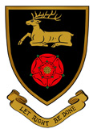
GCSE Exams 2017

Exam Boards
AQA | EdExcel | WJEC | OCR | CAMNAT(OCR)
Art and Design | Business Studies | Media Studies | Computer Science | ICT
English Literature | French | Construction | History
English Language | German | Catering | PE (Sports Science)
Geography | Maths
Resistant Materials | R.E.
Drama | Music
Science
Astronomy

Official Dates
Exams Start Monday 15th May 2017
Exams Finish Wednesday 28th June 2017
Half term 25th May – 2nd June

