

Welcome to New Mills School’s Open Evening 24th September 2026

- Head Teacher Talks are available in the main hall at 5.30pm and 6.30pm
- Inclusion / SEND specific Talks are available in 360 at 6.00pm and 7.00pm

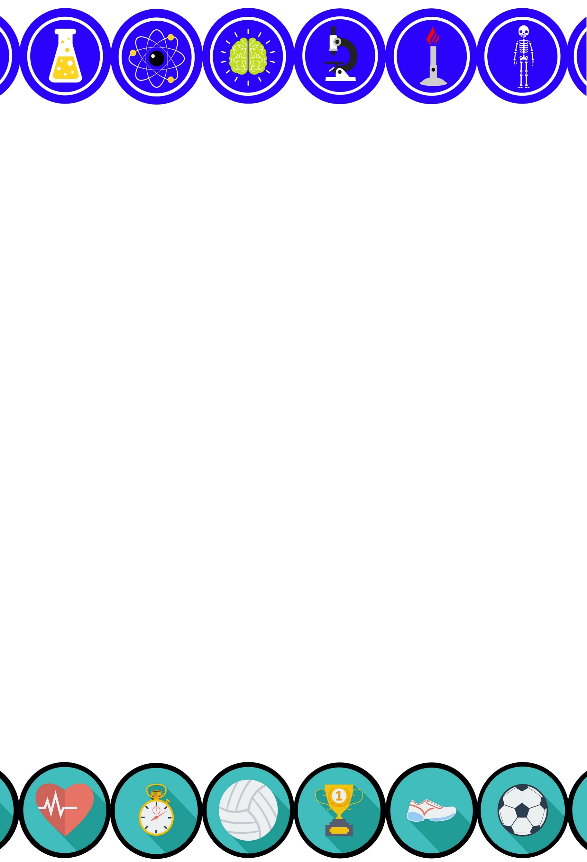
School Map

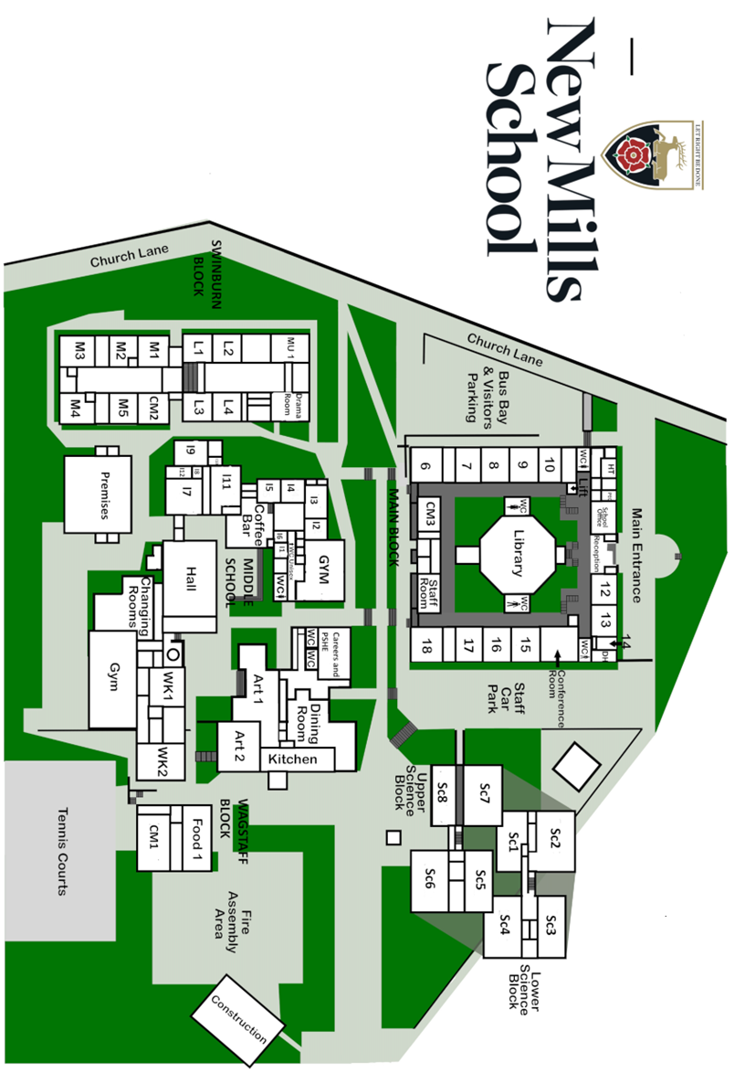

Tea and coffee is available in the school canteen throughout the evening.

In addition, you will find a sample of meals that are available at New Mills School.


Programme of activities this evening:

Department | Activity | Based in
Art | Bob and Roberta Smith signs  Monoprint paper bags | Art 1 & Art 2
Careers and Personal Development | Transition worries  CEIAG games | Engagement Room
Catering | Popcorn tasting  Sugar activity  Hazards in the kitchen | Catering Room
Computer Science | Scratch design | Room 5
Drama | Improv / drama games | Drama 1
Design and Technology | Making a key ring | Workshop 2
English | English themed games and activities  Examples of the texts we study | Library
Geography | Geographical jigsaw puzzle  Where in the world quiz | Room 7
History | Medieval Medicine activity  Timeline match up  Causes and changes | Room 10
Inclusion | Executive function games | 360 area
Maths | Puzzles  Angle target challenge  3D shapes | M1  M2
Media Studies | Online storyboard creation | Room 17
Modern Foreign Languages | Spanish games  Mexican Day of the Dead mask making | L4
Music | Demonstration of band skills | Music 1
PE / Sports Science | Sports challenges  Spin class and gym skills | Gym  Fitness suite
Religion, philosophy and ethics | Matching activity – major religions  What is your idea of heaven and hell?  Colour your own stained-glass window | Room 9
Science | Various science experiments  Dissection of a heart and lung | Science 3  Science 4


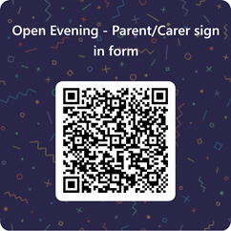

Next Steps
If your child is due to transfer from primary school to secondary school next September (2027), you must ensure that you submit an application for their secondary school place by Midnight on 31st October 2026.
The application process is usually quick and straightforward. We recommend that parents / carers take time to research local schools, attend open events where possible, and carefully consider their preferences before applying.
You can find information about the application process, key dates, and admissions criteria on your local authority's website. If you live in Derbyshire, further information can be found here:
Apply for a school place - Derbyshire County Council
https://www.derbyshire.gov.uk/education/schools/school-places/apply-for-a-school-place.aspx
Please note, if you live outside of Derbyshire, you must apply to your own council and not Derbyshire.

School Tours:
Tours of the school are available over the next few weeks.
If you would like to attend a tour please contact Mr Pete Eckersley, Heads PA either by telephone 01663 743284 (ext. 125) or via email enquiries@newmillsschool.co.uk

Feedback:
We would love to hear about your experiences this evening and
how we can improve moving forwards.
Please access our feedback form via this QR code.

