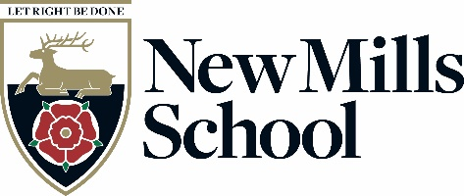
Derbyshire County Council Church Lane
New Mills
High Peak
Derbyshire
SK22 4NR

Tel: 01663 743284
Fax: 01663 745134
Headteacher:
Mrs H Watts
email: head@newmillsschool.co.uk
web: www.newmillsschool.co.uk

Teaching Assistant – Learning Support Assistant (various vacancies)

G5 PP4-5 £25,185-£25,583 pa, pro rata
30 hours per week, Term Time only
ASAP start

Actual Salary for 30 hours per week, for 39 weeks is £17,485.68 - £17,762.04
Hourly rate for Part time is £13.05 ph

Join a thriving school rated ‘Good’ by Ofsted – Inspire Excellence in our students!

New Mills School is a small 11-16 secondary school in the High Peak, close to the stunning Peak District National Park, yet within easy reach of Stockport and Manchester.

Following a very positive Ofsted report rating us ‘Good’ in all areas, we are looking for exceptional Teaching Assistants to join our team. Ofsted praised our ambitious leadership, high-quality teaching, and strong student attitudes to learning, and we are now seeking some inspirational Teaching Assistants to support our successful Faculties and SEN Department.

You will find New Mills School a warm, welcoming place, where we are proud of our inclusive ethos, high expectations, and strong sense of community. Our values—Think Big, Do the Right Thing, and Team Spirit—underpin everything we do. We believe in the power of education to transform lives and are looking for Teaching Assistants who share this passion.

You should be a strong team player, looking forward to joining our school at an important time in its’ development. If you feel you share our values, have the vision and drive for excellence and want to be part of an enthusiastic, dedicated and well-resourced team, committed to ensuring that students fulfil their potential, then we would like to hear from you.

We have a number of vacancies. The working hours of support staff who are supporting students in their learning are would be Monday to Friday 8:35am to 03:05pm. Please be clear in your covering letter whether you wish to be considered for part time or full time hours.

Application packs may be obtained from, and should be returned to Pete Eckersley, Office Manager, New Mills School, Church Lane, New Mills High Peak, SK22 4NR, or via email to jobs@newmillsschool.co.uk or from the school website www.newmillsschool.co.uk.

If you would like to discuss the post further, or arrange a visit to the school, please contact jobs@newmillsschool.co.uk and this can be arranged.

New Mills School is committed to creating a diverse workforce. We will consider all qualified applicants for employment without regard to sex, race, religion, belief, sexual orientation, gender reassignment, pregnancy, maternity, age, disability, marriage or civil partnership.

New Mills School is committed to safeguarding and promoting the welfare of children and young people and expects all staff and volunteers to share this commitment.

The successful applicants' appointments will be subject to satisfactory pre-employment clearances including references and a Disclosure and Barring check.

Closing date is 08:00 Monday 23rd February 2026
Interviews to be held later that week or w/c 2nd March 2026

Kind Regards

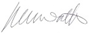
Heather Watts
Headteacher

