10 Best GCSE Revision Tips from Past Students

1. Create a Revision Timetable
Building a revision timetable can add structure to your revision and help you identify which GCSE subjects you need to prioritise to get better marks. Creating a revision timetable is a great way to organise your study time, plus it also helps boost your motivation to revise for your exams.
Be specific with the information in your timetable. Do not just put a subject down but detail what it is in that subject that you are going to revise. This way you can plan to cover all of the course content

2. Use Mind Maps to Connect Ideas
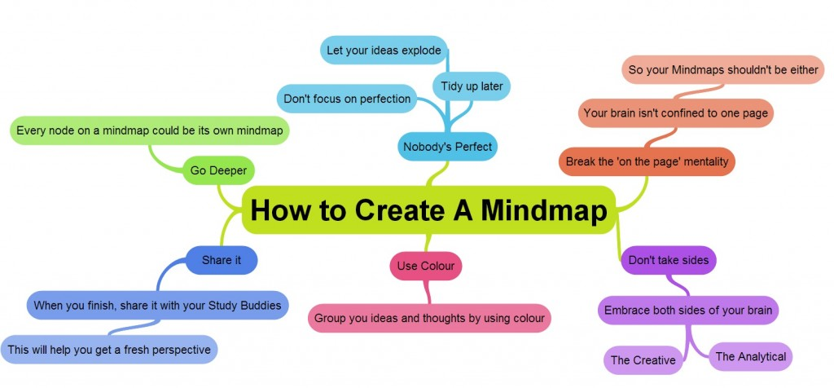
If you find it difficult to remember tons of new study notes, Mind Maps may be the key to improving your memory. The theory behind mind mapping explains that making associations by connecting ideas helps you to memorise information easier and quicker.

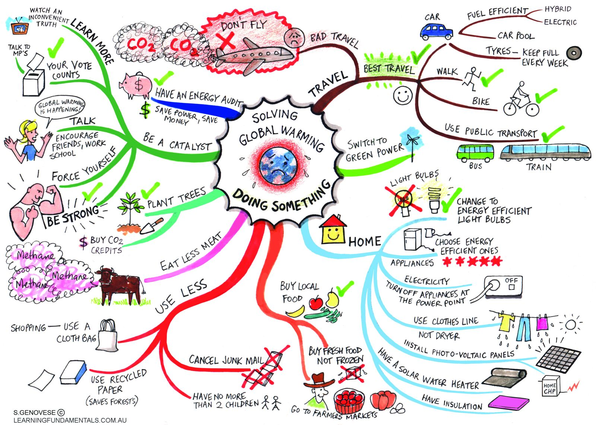

3. Take Regular Study Breaks
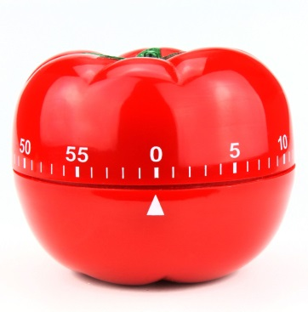
Do you feel stressed, tired and that no new information is entering your head? There is no point forcing yourself to study for hours upon hours as this will not result in a positive outcome. Taking regular study breaks and exercising is proven to engaging your brain in studying and improve your exam performance in the long-run.
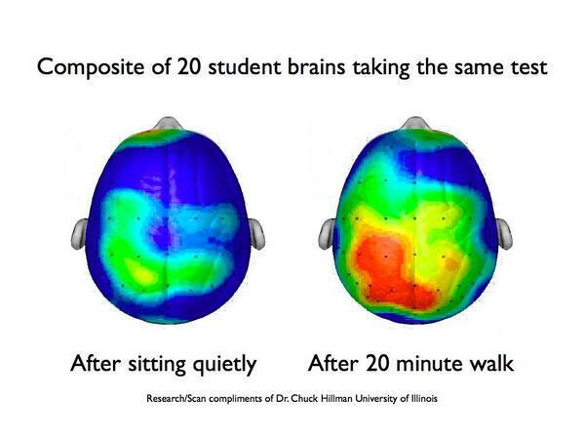

4. Understand Your Learning Style
Everyone thinks that there is a best way to study but the reality is that each person is different. Once you understand whether you are a visual, auditory, reading/writing or kinaesthetic learner, then remembering and recalling new information will become much easier. Practice will also tell you if you work better studying during the night or in the morning/daytime.
5. Practise, Practise, Practise
One of the biggest recommendations that past GCSE students recommend is to do as many GCSE past papers as you can. Practising past papers will help you get familiar with the exam format, question style, time pressure and overall improve your ability to retrieve information quicker.
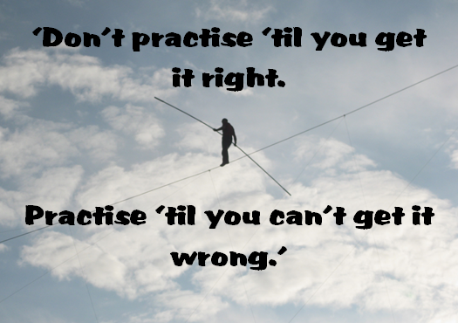

6. Collaborate with Classmates
If you find your coursework to be too much, why not divide the course study notes between trustworthy classmates and share your notes with each other. This will reduce the amount of workload you need to do to prepare for your GCSEs plus you will gain an insight into how other students learn.

7. Variety
Mix up your study habits and methods by listening to podcasts, watching videos or documentaries, moving to new study area or even something as simple as using different colours for your study notes.
This is different to the other GCSE revision tips mentioned here as it encourages you to try a few different things to see what fits for you. Your brain will recall where you were or how you revised for a topic which will help you remember more information. Give it a go!

8. Day of Your GCSE Exam
The day of your exam can be the most stressful of the entire examination experience but there are ways which you can minimise your anxiety such as avoiding panicking friends, giving yourself plenty of time to get to the test centre plus don’t underestimate the power of eating a healthy breakfast the day of your exams!

9. Adapt for Different GCSE Subjects
It may seem obvious but many students try to study for different subjects using the same study methods. Your GCSE revision should take account of the difference between your subjects and the challenges they represent.
For example, Flashcards are an ideal study aid to help you prepare for a Spanish, French, German and exam such as GCSE Science where you need to remember key definitions. An Online Quiz is a great way to test your GCSE Maths skills while you would highly benefit from using a Note to study English.
Once you understand that your subjects need to be approached differently, there is no stopping you!

10. Apps for Students
If you want to stay ahead of your friends with the latest technology, get the best student apps before anyone else. Not only will they help you show off to your friends, some apps such as GCSEPOD are designed to improve your learning.

